

**Placement Empowerment Program**

***Cloud Computing and DevOps Centre***

**Write a Shell Script to Monitor Logs**Create a script that monitors server logs for errors and alerts you.

**NAME:** SHAHANA.M.S **DEPARTMENT:** ADS



**Introduction**

**Log monitoring is a crucial aspect of server administration, ensuring the system's health and security. By analyzing logs, administrators can identify errors, security breaches, and performance issues in real time. Writing a shell script for log monitoring automates this process, making it efficient and proactive.**

**Overview**

**The goal of this shell script is to continuously monitor server log files for errors or specific patterns. When an issue is detected, the script will generate alerts, such as sending an email, logging to another file, or notifying through other communication channels. This script is useful for system administrators to maintain system integrity and troubleshoot issues effectively.**

**Objective**

* **Automate the monitoring of log files.**
* **Detect and highlight errors, warnings, or critical events.**
* **Generate real-time alerts to notify administrators.**
* **Improve system reliability and reduce downtime.**

**Importance**

* **Early Error Detection: Helps identify and resolve issues before they escalate.**
* **Security Enhancement: Detects suspicious activities, such as unauthorized access attempts.**
* **System Performance Monitoring: Tracks server health and resource utilization.**
* **Automation & Efficiency: Reduces manual log-checking efforts, saving time for administrators.**

Step 1: Create a log - testlog.log in your desktop with some commands like:

[INFO] Server started successfully

[WARNING] Disk usage is high

[ERROR] Database connection failed

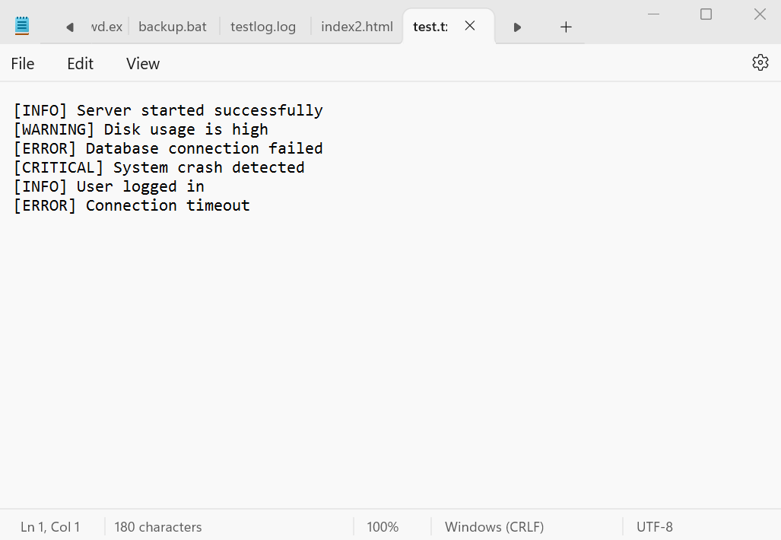

Step 2 Open PowerShell Press Win + R, type powershell, and hit Enter to open PowerShell.

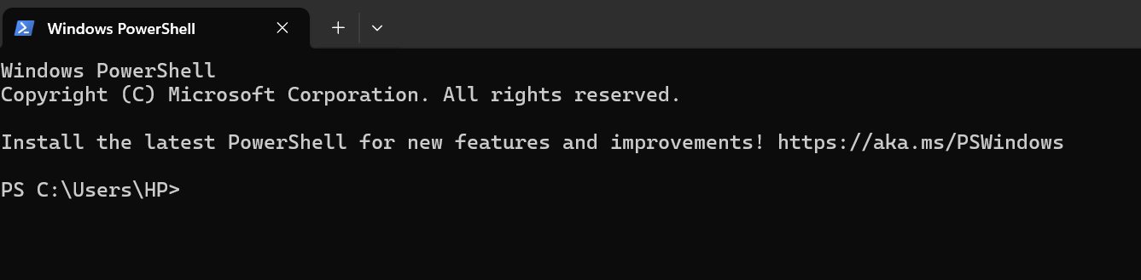

Step 3 Open Notepad and copy the following script:

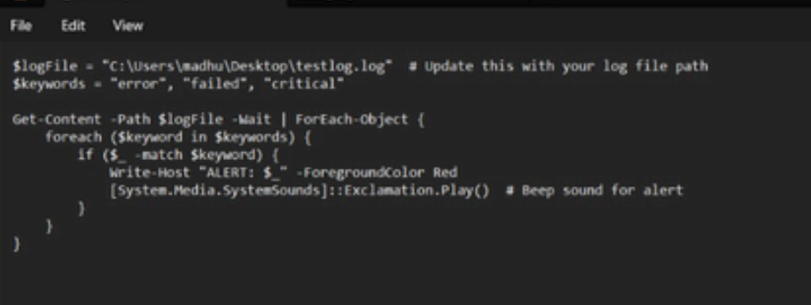

Step 4: Run the PowerShell Script. Open PowerShell and navigate to your Desktop using the command:

